AAUW FALLS CHURCH FLASH

Volume 73, Number 3

March 1, 2023

Presidents’ Messsage

“The heyday of a woman’s life is the shady side of fifty.” Elizabeth Cady Stanton
Dear Members,
Spring approaches and we are full of ideas and plans!
Our Annual Meeting on March 13. It is time for our annual meeting at which we elect officers—VP-Membership (or Co-VPs) and Treasurer. Please attend the meeting on March 13, 2023, at 7:30 via Zoom so we can accomplish these important tasks with the required quorum present. (Zoom link, agenda, and other documents will be sent out 24 hours before the meeting.) Three members have stepped up and, if elected, have agreed to serve: Diane Bodeen and Peggy Howard as co-VPs for Membership, and Linda Lawrence to continue as Treasurer. Let us honor them by showing up to vote!
May 19-20 Book Sale; Book Collection Begins March 4. An important decision was made recently to hold a modified book sale. WE WILL BEGIN COLLECTING BOOKS ON SATURDAY, MARCH 4, 2023, 10:30 TO 1:00 PM. This AAUW FC Members Only Open House/Book Collection event will feature book sale enthusiasts from FC AAUW branch reaching out to fellow members/book lovers with bagels and a tour of the new, free book sorting and storage facility. The storage facility is the former Beyer Volvo Showroom at Gordon Street/Route 7 (just across the street from the Giant at Haycock/Route 7). The last day of book collection will be Saturday, May 13, 2023. MAY 19 - 20 IS THE BOOK SALE! More details below.
March 20, A Private Tour: Women of The Freer Gallery. We will recognize Women’s History Month with a free, private, guided tour of Women of the Freer. The tour will introduce you to influential women through history depicted at the Freer, and some of their recently re-discovered stories. The tour starts at 11:00 a.m. Meet at 10 a.m. at East Falls Church Metro and ride down together. We need at least 10 people, so please sign up in advance by contacting Sharon.Zackula@gmail.com and let me know you will attend. Friends and spouses always welcome!
We are engaged in preliminary discussions with another branch – McLean – to determine if by coordination and cooperation regarding a limited number of programs and activities, we could make a greater impact on our community, program more effectively to further AAUW-aligned policies and goals and be more persuasive as we try to influence policy, law, and regulation in our community.
Thank you, Aida and Mollie Jewell, for an informative and timely program on February 12 from Holly Hazard, a co-founder of 4 Public Education, an organization that is aligned with several of our most important public policy efforts this year in the VA legislature to protect certain freedoms in public education.
We hope to see you on Monday, March 13, 2023, at 7:30 p.m., via Zoom, Saturday, March 4, 2023, at 10:30 with some books in hand and Monday, March 20, at East Falls Church Metro at 10 a.m. to go to the Freer Gallery for our free tour of the women of the Freer!
Co-Presidents
Aida Loomis and Sharon K. Zackula

save the date

VPIS Bazaar/AAUW BOOK SALE FRIDAY & SATURDAY, MAY 19-20

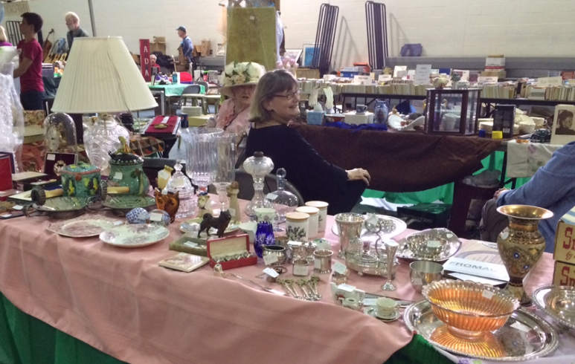
Get your May calendars out and mark the 19th and 20th for our annual Book Sale!
First, we’re excited to be back doing what we have become famous for in the community. Then, new and exciting this year is our partnership with the Village Preservation and Improvement Society (VPIS) who will share the Falls Church Community Center Space with us. Half the gym will be filled with book bargains galore, and the other half with attic treasures! Not only will two vibrant community organizations be doubling the shopping fun for our combined audience, but also halving the expenses to each organization.
Book collection begins this Saturday, March 4, 10:30 am-1:00 pm at a special AAUW Members Open House at the old Beyer Volvo Showroom, (the corner of West Broad and Gordon Road, across from the Giant) with bagels, cream cheese, coffee, conversation, friends, and a tour of the beautiful temporary storage and sorting facility donated by Beyer Auto. Gather your winter reading materials and bring them along with those you can collect from friends, family, and neighbors. We are only taking saleable books in GOOD CONDITION in the following categories:
- FICTION
- NON-FICTION
- CHILDREN’S
- COLLECTIBLE/SPECIAL BOOKS
We will no longer accept reference materials, textbooks, sociology, religion, self-help, philosophy, cookbooks, or magazines.
VPIS will be collecting gently used household goods, small furniture, children’s’ items, music, art, sports equipment, etc. Watch for further information about where and when to deliver but start your spring cleaning now!
The Book Sale and Bazaar will be held on Friday, May 19 from 10 am – 8 pm, with a special 9:00–10:00 am “Special Entry” time for book dealers and collectors. This will be for the AAUW Book Sale only with tickets priced at $10. Saturday, May 20th the sale will open at 9 am and end at 3 pm.
There will be sign-up sheets for volunteers to sort and/or sell/set-up at the March 4 AAUW Open House. There will also be promotional materials we hope you will take back to the businesses in your neighborhoods for posting. If you cannot attend the AAUW Open House, here is a link to the online sign-up sheet https://www.signupgenius.com/go/4090444A9A62CA5FF2-book.
Thank you to VPIS for reaching out to us to make this event for both of us so much more impactful. Doubling our exposure, doubling the shopping experience, doubling the benefit to the community. As Aida has stated so perfectly, “It takes a village….”
Hope to see you Saturday at the Open House… old Beyer Volvo showroom, 1119 West Broad Street, Falls Church, on the corner of Gordon Road, 10:30-1:00 pm.

Pizza Party Fundraiser!
We are gathering at Pizzeria Orso on Wednesday, April 25th to enjoy Falls Church’s best pizza and other Italian specialties while raising funds for our branch. The restaurant is giving back 15% of all proceeds from our group’s food purchases this evening, so bring family and friends for perhaps the most enjoyable way to raise funds for AAUW!

Public policy updates

Virginia General Assembly Update
Denise Murdeen and Janine Greenwood
Co-VPs, Public Policy
AAUW of Virginia

The General Assembly session concluded on Saturday without agreement on the state budget. The House and Senate joint budget conference committee will have to continue its work. The GA will also reconvene on April 12 for the “Veto Session” to deal with any vetoes by Governor Younkin of the legislation it managed to pass.

This short session of the Virginia legislature saw deep partisan divides. With the Republicans in control of the House of Delegates and the Democrats in control of the Senate, the votes continued a trend of lawmakers of both parties opposing each other’s controversial legislation and killing them in committee hearings. Disposing of the most controversial bills without a floor vote of the entire chamber enabled politicians to avoid going on the record in a way that could haunt them in the 2023 election.

Here is a summary of the outcomes in our key legislative and policy priorities:

Education

- The bills AAUW-VA we were concerned about that would have diverted state education funding of public schools into so-called “savings” (voucher) accounts died in committee and did not receive a general vote.

- Two bills that would have restricted transgender students’ participation in school athletics and required officials to notify parents if their child identifies as trans in school were defeated in the Senate. Supporters said the bills would have promoted fairness for female athletes and protected parental rights. The measures cleared the floor of the Republican-controlled House of Delegates meaning that no legislation on school accommodations or health care for trans children will reach Gov. Youngkin’s desk.

- A Senate committee killed multiple bills from the House that aimed to increase parental oversight in public schools. Bills defeated by the Senate Education and Health Committee included proposals to require that parents be notified and allowed to opt their children out of presentations or performances by outside groups and mandate parental involvement in the crafting of library policies.

- AAUW-VA will continue as a member of the Fund Our Schools coalition which we joined this year. The coalition gives us additional resources to advocate for public school funding, one of our top legislative priorities. We ask that you use their portal https://www.fundourschoolsva.org/fund-our-schools-in-the-state-budget/ to ask lawmakers to ensure that public schools are fully funded in the ongoing budget talks that now continue after the conclusion of the GA session.

Reproductive Rights & Abortion

- All the abortion bans were buried or defeated prior to crossover, but there were still some harmful anti-abortion bills that did move to the State Senate. The Senate Education and Health Committee defeated two that stigmatized health care. Delegate Greenhalgh’s bill would have interfered in the patient-provider relationship by reinstating medically unnecessary biased counseling for abortion patients, and Delegate Freitas’s bill threatened to criminalize health care providers.
- A bill that would have mandated that the Virginia Department of Health list crisis pregnancy centers on its website was defeated in the Senate Rules Committee. Crisis pregnancy centers are fake health care centers that mislead pregnant people, and the American Medical Association has called them “unethical.”

- Unfortunately, the constitutional amendment that would allow voters to enshrine a right to reproductive freedom in our constitution was defeated in the House Courts of Justice Subcommittee 1. This subcommittee had considered the House of Delegates version of this legislation and rejected it previously. The State Senate version had passed on the State Senate floor on a vote of 21-18.

- A bill that would have protected online menstrual tracker data from subpoenas was defeated in the House, along with the Contraceptive Equity Act, which would have required health care insurers to provide coverage for contraceptives.

- For a full review of what happened in the reproductive rights and abortion arena, you can Join Planned Parent Advocates of Virginia (PPAV) on Thursday, March 2nd at 6:30pm for their virtual Post Legislative Session briefing. Senate President Pro Tempore Louise Lucas will be joining as a special guest. Register through this link.

Workplace Rights

- Efforts to expand Paid Family & Medical Leave and Paid Sick Leave were defeated in House committees.

- Both a salary history ban bill and a mandate for workplace harassment training were defeated in House committee

- One bright spot was passage of the “Silence No More Act” would prohibit non-disclosure and non-disparagement provisions in employment contracts or settlement agreements if the contracts were to bar discussion of conduct at a past workplace, at work events, and between employees and employers.

Voting Rights

On February 17, 2023, the Virginia Senate passed HB1948 (Bloxom), which the House passed unanimously on February 2, removing the witness requirement for absentee ballots beginning July 1, 2023. Instead, voters will be required to provide the last four digits of their social security number along with their date of birth and signature.

Electronic Meetings

A bill to expand electronic meetings was tabled in the House.

Virginia made history this month with the election of its first Black woman, Jennifer McClellan, to the U.S. Congress.

2023 is going to be an active election year in Virginia with the entire General Assembly up for election. At our next Public Policy meeting on March 30, we will discuss how we can inform our members and other voters about candidate positions on our Public Policy priorities.

Alliance of Hippocratic Medicine v. FDA

A coalition of anti-abortion advocates filed a lawsuit in Texas against the FDA claiming that the agency did not have the authority to approve the drug mifepristone, one of two drugs used in combination for medication abortions. The plaintiffs claim that the drug is “dangerous”, although it has been used for over 20 years in combination with misoprostol for early abortions. The FDA approved the use of mifepristone in most cases up to 10 weeks of pregnancy. The defendants have asked the Judge in the case for a preliminary injunction, which would, in effect, block access to the drug nationwide until the case is heard and longer if the Judge rules for the plaintiffs. A ruling on the preliminary injunction is expected soon.

Our FUNDRAISING FUTURE

In February, members of the Fundraising Task Force presented their proposals for branch fundraisers so we can continue our mission of educating women and girls, especially those living in our Falls Church area. Four fundraisers were supported by the branch membership: a streamlined used book sale that would be in collaboration with VPIS Bazaar, Dinner at Pizza Orso, Gently Used Jewelry Sale and a Direct Appeal to members and friends.

We are moving ahead with the Used Book Sale and Dinner at Pizza Orso this spring and the jewelry sale and direct appeal are planned for the fall. The planners of these fundraisers are hoping that they can count on members for their time, talent, and treasure so that we can build on our 40-year history of fundraising.

Do you have books or jewelry that you are willing to donate? Can you ask friends for book and jewelry donations? Can you invite them to our book/jewelry sale and fun dinner at Pizza Orso? Can you tell friends our story and the impact we have made so that they would consider donating?

Is the fundraising task force work done? No, our work continues. There are some great ideas that continue to incubate and need to be further explored, and new ideas show up regularly. Have you recently attended a fundraiser that may be a good match for the branch? Let us know! Do you know someone who has recently organized a fundraiser? Can you make an introduction? There are many ways to help and get involved.

What can you do to feel proud to say I am a member of the Falls Church Area AAUW?

Branch news Around the Northern District

The Alexandria Branch will sponsor a Zoom program with Nancy Morgan, Coordinator of the Virginia Chapter of American Promise who will discuss her work to pass an amendment to the U.S. Constitution that would “set reasonable limits on the raising and spending of money to influence our elections.” As part of the program, she will talk about the status of money in our political process, review policy options to address this issue, and explore actions citizens can take to influence legislation.
Sunday, March 12, 2:00-3:30 pm on Zoom
To join the meeting:
https://us02web.zoom.us/i/84385455094
Meeting ID: 843 8545 5094

The Springfield Annandale Branch will hold their Spring Fling on Friday, May 5 at the Springfield Golf and Country Club. Renée Wynn, former Chief Information Officer for NASA will speak on “The Benefit to Humanity of Space Exploration”. There will be a silent auction and luncheon as well. Deadline is April 24 for reservations. The price is $50 and to reserve your spot go to: https://www.eventbrite.com/e/aauw-2023-spring-fling-luncheon-and-silent-auction-tickets-533676931067?aff=erelexpmlt

The Northern District Meeting held on Saturday, February 25 introduced us to two organizations pursuing missions similar to our own: Generation Hope https://generationhope.org whose mission is to ensure all student parents have the opportunities to succeed and experience economic mobility; and Women Giving Back https://womengivingback.org whose mission it is to help women and children in crisis by providing clothing at no cost. For more information about these inspiring groups, we encourage you to visit their websites.

movie and book groups

Let’s Go to the Movies
Virtual Movie Club

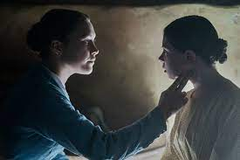
Books seem to be a starting point for many films. It was true with Where the Crawdads Sing, The Good Nurse and continues to be true with our next film selection The Wonder which is based on Emma Donahue's novel. The story takes place soon after the Great Famine. An English nurse, played by Florence Pugh, is sent to rural Ireland and is assigned to watch a young girl who purportedly has not eaten in four months and yet is remarkably healthy. Along with a nun, they are to document and report their findings independently to local officials. What is happening? Is the village harboring a saint or other motives at play?
Watch The Wonder on Netflix Streaming. Join the group on zoom on Wednesday, March 22nd at 7:00 PM. Please call or text Aida at 703 966 8050 if you are interested in joining any of our film discussion evenings. All are welcome!
Upcoming attractions:
April: How Long Must We Wait (watch on YouTube)
https://www.youtube.com/watch?v=nrwqUPYlp28
_________________________________________________________________________________________

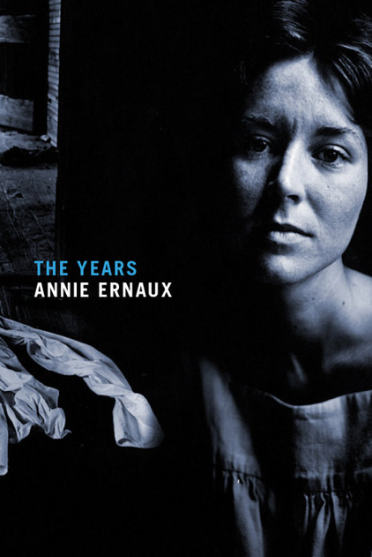
Book Group News
Up next: The Years

Meeting Date: Tuesday March 21st, 7:30 PM via Zoom. Please join us or a lively discussion and watch for an email with the April and May selections.

The Years by Annie Ernaux, Alison L. Strayer (Translator) won the Nobel Prize for Literature in 2022. It is considered by many to be the iconic French memoirist’s defining work and a breakout bestseller when published in France in 2008. The Years is a personal narrative of the period 1941 to 2006 told through the lens of memory, impressions past and present—even projections into the future—photos, books, songs, radio, television and decades of advertising, headlines, contrasted with intimate conflicts and writing notes from six decades of diaries.

The Zoom invitation will be sent out the date before.

share your professional expertise with students

Marybeth Connelly, a member of AAUWFC, and Director, Strategic Planning and Community Engagement for the Falls Church City Schools reminds us that the Meridian HS Career Chat Program is back in person and is excited to welcome professionals from many careers to chat with their students. The opportunity for students to meet real people and learn about different career choices and achievements is invaluable as they begin to think about life beyond high school. All professions and career paths are welcome!

There are two more sessions for students this year. They will all be in person from 9:30-11:30 am at the high school.
- Monday, March 20
- Monday, May 15

Please complete this form https://docs.google.com/forms/d/e/1FAIpQLSdN26e8tCfSZWygEj3eEge_64ftGX2ltAiXr8wLkoo6iwu7Wg/viewform if you are interested or reach out to Regan at davisr@fccps.org

There is nothing more rewarding than having your life experiences become inspiration for a young person. We hope you will share yours!

Calendar

- March 4, 10:30 am-1:00 pm: AAUW Open House and Book Collection, Beyer Auto, 1119 West Broad Street, Falls Church
- March 12, 2:00-3:30 pm, Alexandria Branch program “Taking Money Out of Politics” (Zoom)
- March 13, 7:30 pm: Annual Branch Business Meeting (Zoom)
- March 18, All Day: AAUW State Conference in Williamsbueg
- March 20, 11:00 am: Women of the Freer tour
- March 21, 7:00 pm: Book Club (Zoom)
- March 22, 7:00 pm: Virtual Movie Group (Zoom)
- March 28, 7:30 pm: Board Meeting (Zoom)

____________________________

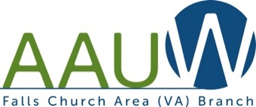
In principle and in practice, AAUW values and seeks an inclusive membership, workforce, leadership team, and board of directors. There shall be no barriers to full participation in this organization based on age, disability, ethnicity, gender, gender identity, geographical location, national origin, race, religious beliefs, sexual orientation, and socioeconomic status.

