AAUW FALLS CHURCH FLASH
Volume 64, Number 1 January 2015

From the Editor
This is an abbreviated edition of The Flash to notify members of two Branch meetings coming up and to share a bit of news.

From the Board :
The Board will meet on January 13th, so there are no reports from the Board at this time. However, there are two interesting programs planned for the January and February Branch meetings that we want to make sure you note.

Programs: The January 25 meeting on Human Trafficking is being co-sponsored by the LWV of Falls Church and Arlington. AAUW of Arlington will advertise this meeting to their members.
At the February 8 Branch meeting, Cindy Moss, Professor, Department of Psychological and Brain Sciences, JHU, will speak about her current work and the benefits to her career of an AAUW Fellowship.

Public Policy Update:
- The Virginia General Assembly will meet in Regular Session in Richmond from January 14-February 28, 2015. You’ll be able to find lots of useful information about the lawmakers and proposed legislation at the following websites: http://virginiageneralassembly.gov, http://lis.virginia.gov, and http://www.richmondsunlight.com.
- Human Trafficking Petition. As of December 29, 2014, the Virginia AAUW had 601 signatures on the human trafficking petition that will be presented to Virginia lawmakers on State Lobby Day (February 4, 2015), which leaves less than a month to meet the goal of 1000 signatures by January 30th. If you have not signed the petition, please do so now at this link: http://bit.ly/1F56cLG. Also, please forward the link to friends, neighbors, and relatives in Virginia, asking them to sign as well. We want to demonstrate to our lawmakers on State Lobby Day that their constituents are interested in additional legislation to provide assistance to human trafficking survivors.
- State Lobby Day is Wednesday, February 4, 2015. The agenda is currently being developed and will be distributed when all the pieces fall into place. However, you should expect an early start (8:30 a.m. or earlier), and we should wrap up after lunch. As in the past, we will be joining the League of Women Voters and other groups at lunch. The location for lunch has not been announced as of yet. If you are interested in attending Lobby Day and/or the lunch, please email Marilyn Falksen at falksen@yahoo.com by January 20, 2015.
- As in the past, several members from the Greater Richmond Branch will graciously be opening their homes to members participating in State Lobby Day, who want to arrive on February 3rd and spend the night. Also, Richmond branch member Kathy Kelley has invited those in town on February 3rd to her home for dinner at 6:30 p.m. Please email Marilyn Falksen by January 12, 2015, if you want to spend the night of February 3 in Richmond and/or have dinner at Kathy Kelley’s home.

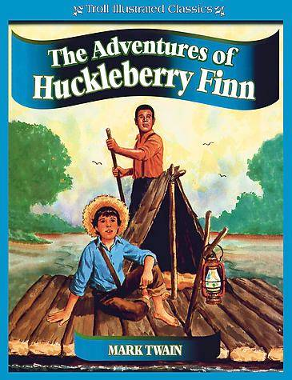
Book Group Plans :
Our January selection is Mark Twain’s Adventures of Huckleberry Finn. Please find time to check out this American classic first published in 1885 that still stirs plenty of controversy. Of all Twain’s novels, Huck Finn sold best at its initial appearance. Many initially condemned it as coarse and currently view it as racist. Plan to come to Becky Gaul’s home at 7:30 pm on Tuesday, January 20th, for an interesting discussion.

Book Sale:

AAUW Sign Making – Jan 17, 1pm.
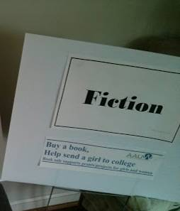Come join us on Sat. afternoon Jan 17 to make new signs for the book sale. We will convene at 1 pm on Sat. afternoon at Mollie Jewell’s house (3715 Tollgate Terrace (ZIP is 22041) in Lake Barcroft, off of Columbia Pike between Bailey’s Crossroads and Annandale). Call Mollie at 703-941-5643 for additional directions.
We will be making signs for all the categories – about 100 in all - following the prototype sign that we selected at the holiday party. The job will be to assemble all the signs. We have ordered the backing (in all the colors: red, yellow, blue, white, and green) and clear contact paper to “laminate” them. We are working on the custom “piece parts” now: Mary Youman is printing all of the categories and Mollie is printing the tag lines.
If you can’t come to the sign making, don’t worry. We will have plenty of other opportunities to help with the sale. In February, we will have an organizing session, and we will be sorting every Saturday starting March 7 right up to the sale. Sale setup will be April 16 and the sale itself is April 17-18.
Book sale sign making – plan to attend
Date: Saturday, January 17
Time: 1pm to 3pm (or so)
Place: 3715 Tollgate Terrace, 22041. Between Bailey’s Crossroads and Annandale (NOT Tollgate Way in Falls Church).

The Movie Group
Members of our AAUWFC Branch plan to attend the movie Selma as a group and discuss it afterwards over coffee or tea. We will go to the Angelika Theater in the Mosaic District on Saturday January 10th in the afternoon. The specific time will be set once the movie times are published. Please contact Kitty Richardson if you wish to join this gathering.
The Movie Group is still viewing the latest from Hollywood! If you want to read one member’s take on the films of the day, go to Susan Conklin’s blog http://suzismovies.blogspot.com/

And consider joining the group any Wednesday; contact Kitty Richardson kittyrichardson6@gmail.com for information.

CALENDAR OF EVENTS

January 25 AAUWFC Branch Meeting, 2:00 pm at the Falls Church Community Center
Topic: Human Trafficking

February 8 AAUWFC Branch Meeting, 2:00 pm at the Falls Church Community Center
Topic: Cindy Moss, Neuroscientist and AAUW Fellowship Recipient, on the benefit of the Fellowship for her career and her scientific work

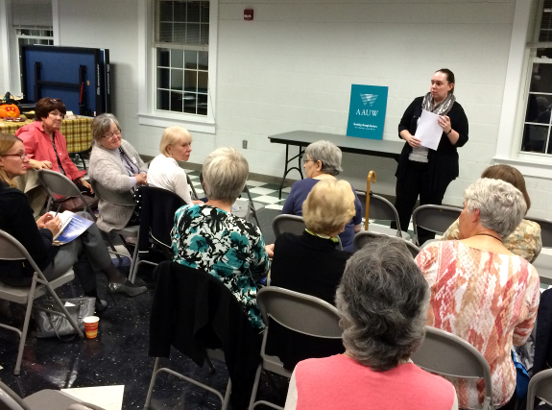There was an interesting discussion at the October Branch meeting on Get Out The Vote! and mid-term election issues.

Empowering Women Since 1881
The American Association of University Women promotes equity for all women and girls, lifelong education, and positive societal change. In principle and practice AAUW values and seeks a diverse membership. There shall be no barriers to full participation in this organization on the basis of gender, race, creed, age, sexual orientation, national origin, or disability.
http://aauw-va.aauw.net

