AAUW FALLS CHURCH FLASH

Volume 64, Number 5 May 1, 2015

BOOKSALE NEWS: Gross of $21,782

- Thank you for your hard work!!

“I am so proud of all of you. Thank you from the GIRLS & WOMEN.” Carol Anne Davis

“Thank you. It’s a lot of work, but it does so much good for deserving students. “ Renee KLish

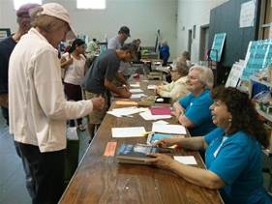

Sales: Olivia Cedillo, Mary Youman, Eunice Bryden, and customers

“Holy Toledo!! This must be a record sales gross? I continue to be amazed at the logistics skills of the AAUW and its chief strategists, Mollie and Mary. Congratulations, all.” Sally Brett

“All I can say is Wow! And many, many thanks!” Sarah John

“I want to also mention the excellent contribution Mollie and Mary give to the effort. Thank you for donating a significant portion of your life each year.” Kitty Richardson

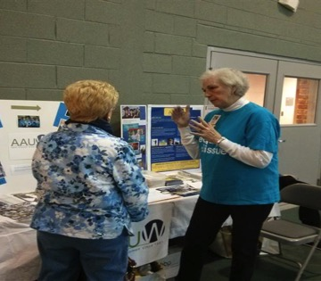

Recruiting new members: Kitty Richardson talking about AAUW to a book buyer at the sale

May 2015
From the President . . .

What a busy April we have had! Many Falls Church Branch members worked setting up books, selling books, and celebrating the Book Sale. Thank you to all of you who gave of your time, talent and energy to make the sale such a huge success. Special thanks to Mollie Jewell and Mary Youman, Book Sale Co-Chairs, for their tireless efforts throughout the year to ensure that all of the big and little jobs got done to make the sale run smoothly and to yield a gross income of $21,782!

On the Saturday of the Book Sale, I represented the Falls Church Area Branch at the Virginia/West Virginia AAUW State Conference in Charlottesville. Susan Conklin was also there in her role as AAUW-VA Vice President for Communications. You will recall from the publicity for the conference that many interesting and useful presentations and workshops filled the day. Linda Hallman, AAUW Executive Director, spoke about the future of AAUW and responded to members in a Q & A session.

Keeping in mind our branch’s upcoming 65th anniversary, I listened carefully to the presentation of AAUW Archivist Suzanne Gould who gave an overview of the history of AAUW from its founding in 1881. Suzanne and a dedicated group of volunteers regularly comb through and organize the archives at the National Office. Our own Northern District Co-Representative Caroline Pickens unearthed a letter from Rachel Carlson expressing her thanks for the 1956 AAUW Achievement Award. Ms. Carlson used the award money to write Silent Spring.

Suzanne distributed Guidelines for Preserving State and Branch Archives. Our 65th year would be a good time to collect our valuable branch records and organize and preserve them for future generations. We regularly archive editions of The Flash and minutes from our Branch meetings at the Mary Riley Styles Public Library, but I am sure there are other records in boxes in basements and attics and under the bed! Archiving was included as one of the afternoon workshops along with campus domestic violence prevention and human trafficking.

We got our policy fix with Recapping the 2014 Midterm Election by Geoffrey Skelley of the UVA Center for Politics. He addressed questions such as: What impact did women voters have? How successful were women candidates? What do the election results mean for AAUW public policy in the short-term and for the future? You can sign up for the Center’s nonpartisan newsletter on American campaigns and elections by going to www.centerforpolitics.org/crystalball.

Next year will be our Northern District’s chance to host the State Conference. The conference is scheduled for April 15-17, 2016 at the Hyatt Dulles. There will be many committees and many jobs to do. It will be fun to get to know other AAUW members in the area as we work together.

Happy Spring to all!

Bunny Jarrett, President

From the Board

The AAUWFC Board did not meet in April due to insufficient business to warrant a meeting. The Board and the members have worked hard to organize our monthly meetings, the Holiday Party, and the Book Sale over the past several months. Our year is drawing to a close with the Scholarship Awards Meeting on Monday, May 11 and our Planning Picnic on June 8. If you have business to come before the Board at their May 18 meeting, please contact Bunny Jarrett, mjarrett@gwmail.gwu.edu.

Notes from the Treasurer

Fiscal year 2015-2016 starts July 1, 2015. You have received an email to renew your dues by credit card. If you click on the link in the email, your account will open with all your information. Al l you need to do is put in your credit card information. Just a reminder $46 of the national dues are tax deductible. You can add a contribution. If you’d like to contribute to The Falls Church AAUW Branch Career Development Grant, please call Martha at 703-533-0706. At this writing it was not possible to do this, but national is working to make it possible.

If you have any receipts from the booksale, please send to Martha Trunk as soon as possible. Please indicate if you’d like payment.

If you have receipts for branch activities, please send those also. Even if you do not want to be reimbursed, it is important to know how much it costs to run the branch.

Membership
Welcome New Members!

Aida Uribe Loomis, joined our Branch in early 2015 after attending our holiday party and the meeting on neuroscience and bats!
Four women joined our branch during the book sale. They are:

Mary Samardzija
Elizabeth Olsen (former member of our branch)
Lee Roussel
Pam Hewitt

PUBLIC POLICY UPDATE

Equal Pay Day
The Falls Church Area Branch recognized Equal Pay Day, April 14, 2015, in several ways. First, our President, Bunny Jarrett, wrote a letter to the Editor of the Falls Church News-Press discussing the gender pay gap, its affect on women and their families, and an important step Congress should take to close it. The letter was printed in the April 9 edition of the News-Press. If you didn’t see Bunny’s letter in the News-Press, a copy of it was included in the April edition of the Flash.
Second, at the request of the Branch, the Mayor of Falls Church proclaimed April 14, 2015 Equal Pay Day in Falls Church. The proclamation urged the citizens of Falls Church “to recognize the full value of women’s skills and significant contributions to the labor force and further encourage [d] businesses to conduct an internal pay evaluation to ensure women are being paid fairly.” At the City Council’s April 13 meeting, the Mayor presented the proclamation to President Jarrett. (See photo on page 5.)
Third, at the annual book sale, members distributed literature about AAUW and the issues it supports, including the AAUW publication, “The Simple Truth about the Gender Pay Gap”. If you would like a copy of this excellent report, please contact the Branch’s Public Policy Chair, Marilyn Falksen, at 703-534-8740 or via email falksen@yahoo.com. We gained four new members and five individuals signed up to be Two-Minute Activists at the book sale.
Transparency and the Virginia Legislature

In February, AAUW of VA joined Transparency Virginia. Founded in December 2014 under the auspices of the League of Women Voters of Virginia, Transparency Virginia’s (TV) mission is to advocate for more transparency and openness to the public in how the Virginia General Assembly carries out its legislative duties. There are over 20 member organizations, including AARP Virginia, ACLU of Virginia, Brady Campaign Richmond Chapter, Fair Elections Legal Network, League of Women Voters of Virginia, NARAL Pro-Choice Virginia, National Active & Retired Federal Employees Association - Virginia Federation, New Virginia Majority, OneVirginia2021: Virginians for Fair Redistricting, Richmond First Club, Virginia Civic Engagement Table, Virginia Coalition for Open Government, Virginia Education Association, Virginia Interfaith Center for Public Policy, Virginia NOW, Virginia Organizing, and Virginia Poverty Law Center.
On April 14, 2015, TV held a press conference and issued a report about the transparency--or lack thereof--during the General Assembly session that adjourned on February 28, 2015. The report is excellent, albeit disturbing. The link for the report is:
https://transparencyvirginia.wordpress.com/2015/04/14/transparency-virginia-legislative-report-2015/

City Council proclaimed April 14, 2015 Equal Pay Day with FC AAUW

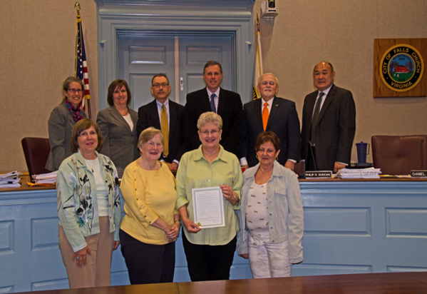
Marilyn Falksen, Anne Baxter, Bunny Jarrett, and Susan Conklin at the April 13 Falls Church City Council meeting at which the Mayor proclaimed April 14, 2015 Equal Pay Day.

May 14, 2015 is Federal Lobby Day for AAUW of Virginia. On that day, Virginia members of AAUW will gather in Washington, DC at 9:30 a.m. to join the members of AAUW's Lobby Corps on their regularly scheduled visits to Congressional offices to educate Members of Congress and their staffs about issues AAUW supports and actions we want them to take.

Participating in this event is a great way to learn about Lobby Corps and to influence legislation that has an impact on women and girls. The State Public Policy Chair is trying to arrange a meeting with one of Virginia's Representatives in Congress, which would take place after lunch. Lobby Corps members typically finish their visits by noon.

If you are interested in participating, please send your name, email address, and name of your representative to the Branch's Public Policy Chair, Marilyn Falksen, at falksen@yahoo.com by May 1.

BOOKSALE NEWS: Gross of $21,782!!
Transforming an empty gym on Thursday morning into the Falls Church AAUW book sale is an amazing sight. The books arrived and were unloaded by 2pm, then the AVID students of J.E.B. Stuart High School were extremely helpful in the set up effort, and we finished in plenty of time for our 6:30 Thursday training session.
Equally amazing is watching 100+ men and women running through the tables to get to their choice spots at 9 am sharp on Friday morning. The gym was full of customers until the sales’ end on Saturday at 4pm. The new signs really "spiffed up" the sale, and our new Square charging system worked like a charm. Thanks to the credit card mavens and all the cashiers who adjusted to a new process with ease.

Through out the sale, FC AAUW members were amazing! By my count (and I may have missed a few), 45 people helped with the sale, sorting, publicity, etc. and some weren't even members.
Our membership recruitment garnered 4 new members (welcome) and lots of discussion about human trafficking and Equal Pay Day. So, our sale also helped "sell" our program At sales-end, with the help of Aurora House girls and George Mason students on Saturday, we were able to empty the gym by 5 pm and enjoy a relaxing Celebration Dinner on Saturday night. Thanks to all who participated in this transformation from beginning to end - from last summer right through the sale.

Bottom Line: Friday was a banner day with cash sales of $11,712 and charge sales of $3,512. Saturday cash sales were $5,538.80 with charge sales of $1,020. This brings us to our bottom line: total gross sales were $21,782.00. Of course we have expenses (still compiling), so we aren't positive about the money for scholarships and grants next year quite yet. (Reminder: if you have reimbursables, send them to Martha Trunk).

This is a group effort and it couldn’t happen without YOU. Thanks to all of you who helped: Aida Uribe Loomis, Anita Cline, Anne Baxter, Becky Gaul, Bunny Jarrett, Chuck Youman, Debbie Pawlak, Diane Bodeen, Edward Levine, Elizabeth Kessell, Eunice Bryden, Gary Jewell, Hope Pillsbury, Jean Zapple, Jim Gaul, Joe Pawlak, Kristan McMahon, Kitty Richardson, Linda Garvelink, Marilyn Falksen, Martha Trunk, Marty Behr, Mary Ellen Ganon, Mary Youman, Megan Brett, Mellen Tanamly, Millie Schriber, Mollie Jewell, Nadyne Rosin, Nancy Cavanaugh, Olivia Cedillo, Pam Martinov, Pat Ferree, Peggy Howard, Peggy Montgomery, Pepper Dittinger, Renate Alison-Rigl., Renee Klish, Richard Youman, Sarah John, Sharon Zackula, Susan Hesser, Uyen Dinh, Vicki Hendershot, and Virgil Bodeen.

In case you missed some of the sale, here are some of the highlights:
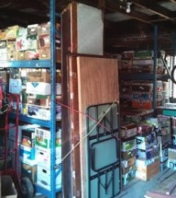, 1. Books at Youman's before sale | 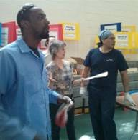, 2. Setup. Becky consulting with Community Center staff on tables | 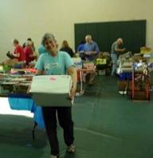, 3. Moving books to tables with sorting in the background
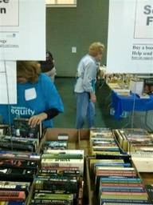, 4. Straightening books | 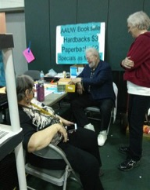, 5. Happy customer (Bill Richardson) talks to Kitty and Nadyne Rosen (FC AAUW alumnae) | 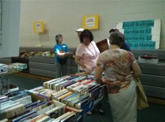  - 6. Becky Gaul and customers
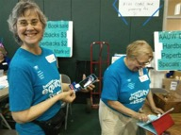  7. Charge-card committee: Becky Gaul and Martha Trunk | 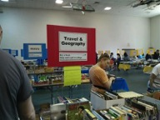  8. Saturday at the sale | 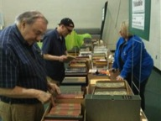  9. Renee Klish selling Specials
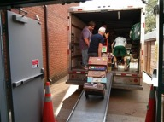
10. Clean out - 5pm Saturday

Mollie and Mary and all of the others,

“Reading Mollie's email makes me think, "I want to be a part of the Book Sale!" Who would not want to join such an effort. The Book Sale is truly a compelling exercise in fundraising, teamwork, and collaboration - and it is a unique opportunity to get to know other members and to be a part of the greater good. A heartfelt thank you to all who helped with the sale.”
Bunny
May Book Group Meeting

Our next meeting will be Tuesday, May 19th, hosted by Martha Trunk. The selected book is I Am Malala: The Girl Who Stood Up for Education and Was Shot by the Taliban by Malala Yousafzai with journalist Christina Lamb. The book recounts the early life of the Pakistani schoolgirl who spoke out against the Taliban, was shot for her defiance, and became a powerful symbol for girls' universal right to an education. Please come!

Movie Blog
The Movie Group is still viewing the latest from Hollywood! If you want to read one member’s take on the films of the day, go to Susan Conklin’s blog http://suzismovies.blogspot.com/ And consider joining the group any Wednesday; contact Kitty Richardson kittyrichardson6@gmail.com for information.

Tinner Hill Blues Festival

The Tinner Hill Heritage Foundation and the City of Falls Church host the annual Tinner Hill Blues Festival each June.

The festival celebrates the hill where the first rural branch of the National Association for the Advancement of Colored People (NAACP) was founded and features a variety of music from the Afro-Brazilian, urban, gospel, and blues genres; traditional African-American cuisine and craft vendors; and the annual E.B. Henderson "Dear Editor" awards.

A Boogie Woogie Blast is scheduled for June 12th. at the State Theater; Saturday there is an all day event in Cherry Hill Park with many musicians performing.

For more information go to: http://tinnerhill.org/blues-festival

The Northern District fall meeting will be Saturday, October 3, 2015. It will be held at one of the Fairfax County Public Libraries. Recent meetings have focused on violence in the military and campus sexual assault. If you have topics or speakers to suggest for the October meeting, please contact Co-Representatives Caroline Pickens at carolineaauw@gmail.com or Jeanne Elmore at jeanneelmore@yahoo.com.

The History of the American Association of University Women of Virginia 1925-2010.

This book published by AAUW in 2014 contains the history of the first 85 years of AAUW of Virginia written in three parts. The first, covering years 1925-1960, was written by Dr. E. Marion Smith of Hollins College. The 1960-1970 segment was composed by Mary Wright Thrasher of Norfolk and Bernice B. Lovitt of Virginia Beach. Both had served as state presidents in the 1960s. Neola Waller, state president (1998-2002) from Virginia Beach, compiled the 1970-2010 record. The first two were copied in their original form. Spellings and expressions were left unaltered to preserve historical accuracy. Every AAUW branch in Virginia will receive a free copy of the book. Bunny Jarrett picked up the copy for Falls Church at the recent state conference. The book can be ordered through AAUW at www.aauw.org.

Hunting Ground Shown at GM

The Boston Globe article by Ty Burr on March 12, 2015 said: “ ‘The Hunting Ground’, a documentary about campus rage, is as unsubtle and unsettling as a hammerlock. It’s also as effective. Director Kirby Dick and producer Amy Ziering, who tackled sexual assault in the military in ‘The Invisible War’ (2012), amass statistic upon statistic, horror story upon horror story, to present a case that’s damning and seemingly inarguable.”

George Mason University’s (GMU) Department of Wellness, Alcohol, and Violence Education and Services (WAVES) joined with the department for Women and Gender Studies to raise awareness about sexual violence on campuses by screening “The Hunting Ground” on April 16th. The film was part of GMUs annual week-long effort to raise awareness about cooperating to create a safe campus environment. The AAUW of the Falls Church Area provided a Special Projects Grant of $200 to pay half the cost of the screening fee.

The almost two hour film interviews numerous victims of campus sexual assault and many college/university administrators from schools across the country. Numerous universities are profiled, including University of Virginia.

Some statistics sited by Burr from the movie are astounding. “1 in 5 women will be assaulted during their college experience; the percentage of false claims, 2 percent to 8 percent, is the same as for other crimes.” He also quotes, “8 percent of men in college are responsible for 90 percent of all assaults.”

The film is strongly critical of the inadequate response of administrators on many campuses. Concern for their “brand” and their alumni contributions leads to mistreatment of the incidents and the victims.

Burr points out ‘The Hunting Ground’ would “be merely a screed of numbers and outrage without the heroes at the center: The young women – in the dozens – who come forward to tell their stories, pushing past shame and shedding their anonymity.” Two of these heroines filed a Title IX charge against the University of North Carolina (UNC) in 2013 resulting in the US Department of Education opening an investigation into how UNC handles sexual assault cases.

The screening in Robinson Hall theater was well attended. Representative from WAVES along with staff of Women and Gender Studies coordinated the event. GMUs Title IX coordinator participated in the Q&A that followed the screening. Another film viewer who came forward to do Q&A was GMU President Ángel Cabrera. He pledged his commitment to open discussion and encouraged all segments of the GMU community to work towards the safety and support of all.

CALENDAR OF EVENTS

May 11 Scholarship Awards meeting, 7:30pm, Woodrow Wilson Library, 6101 Knollwood Dr. Falls Church, 22041-1798
Telephone: 703-820-8774

June 8 Planning Picnic, details forthcoming

Empowering Women Since 1881
The American Association of University Women promotes equity for all women and girls, lifelong education, and positive societal change. In principle and practice AAUW values and seeks a diverse membership. There shall be no barriers to full participation in this organization on the basis of gender, race, creed, age, sexual orientation, national origin, or disability.
http://aauw-va.aauw.net

