***AAUW FALLS CHURCH FLASH***

***Volume 64, Number 4 April 1, 2015***

### *Book Sale April 17 and 18*

**Patrick & Becky found lots of donated books at the FC Community Center collection point**!

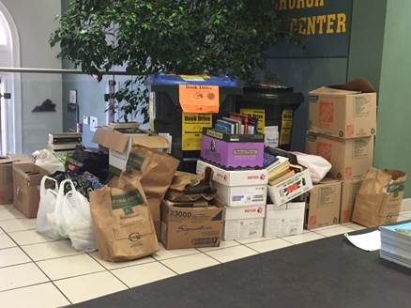

**April 2015**

**From the President . . .**

As we move toward the end of the year, I am thinking about two things I want to share with you.

One is the formation of a **Fundraising Committee** to develop an overall fundraising strategy for our branch. This committee will be formed in June and will begin their work in September. Please let me know if you would like to volunteer for this committee. We want those of you who know something about fundraising, those who know something about the book sale, and those who know a little or a lot about our branch. The more input we have, the better our decisions will be.

The second item is our **65th Anniversary Celebration**. We brainstormed ideas for the celebration at our recent Board meeting. We thought if we held the celebration in September, it would be a wonderful kickoff for the year and a terrific way to welcome new members. A tea or a luncheon was suggested with special invitations going to former members. We thought about interviewing a selection of members about their memories of AAUWFC over the years and publishing the interviews in the event program. We got pretty excited talking about how we might celebrate our anniversary!

Kristan McMahon volunteered to collect ideas about the celebration before a 65th Anniversary Committee can be formed. Take a few minutes to think about what you would like the branch to do to celebrate. Remember that we are in the brainstorming stage, so any and all ideas are welcome. Send your ideas to Kristan at [kkmcmahon@gmail.com](mailto:kkmcmahon@gmail.com).

1. What kind of celebration would you like?
2. Where do you suggest we have it? Do you belong to any clubs where we might reserve a nice room?
3. What speakers or topics do you think would fit the occasion? If you know of a specific person, tell us her/his name, possible topic, and contact information if you have it.
4. What part of the celebration would you most like to help with? Gathering old pictures, newsletters, etc. for display? Locating a venue for the event? Helping with the written program preparation? Other areas?

If you want to be on the Celebration Committee, let me know at [mjarrett@gwmail.gwu.edu](mailto:mjarrett@gwmail.gwu.edu). I anticipate having a large committee so that no one person has to spend a great deal of time preparing for the event. I would like to finalize the committee in May so that we can jump into the planning process.

Oh, and there is the **Book Sale**. Many of you indicated at the March meeting that this was the thing you enjoyed most about our branch. Come out to sort on Saturdays, volunteer to give out book marks at the Farmers Market Saturday mornings, put signs in your local store or library or condo building, and come out and sell books on April 17 and 18!

Bunny Jarrett, President

**From the Board . . .**

The Board met on March 23.Present: Becky Gaul, Bunny Jarrett, Mollie Jewell, Kristan McMahon, Kitty Richardson, and Martha Trunk.

**BOARD MEMBER REPORTS**

**Programs: Kristan McMahon**

Kristan reported that Kitty has reserved a room for the May 11th Scholarship Awards meeting at the Fairfax County Woodrow Wilson Public Library in Culmore after finding the Community Center could not offer us an appropriate room. The meeting will start at 7:00 pm, and we must vacate the room by 8:55.

The Board brainstormed ideas for our 65th Anniversary celebration. It was suggested that we have the celebration in September as a kickoff to the year and a welcome to new members. A tea and a luncheon were suggested. Kristan agreed to be the repository of suggestions and recommendations for the event until an anniversary celebration committee is formed.

It was agreed that Bunny would write a letter to the Falls Church Parks and Recreation Department requesting that they install wifi at the Community Center.

**Membership: Kitty Richardson**

Kitty reported that no nominee for president has been found. She is reviewing information about alternative leadership structures. Kitty will prepare the membership table for the Book Sale.

**Treasurer’s Report: Martha Trunk**

Martha indicated that we have few expenses during the past month. She continues to encourage members to submit reimbursable and non-reimbursable expenses. Bunny reported that Anne Baxter has agreed to perform an audit of the books at the end of the fiscal year.

Martha and Becky reported on the use of *Square* on members’ phones or ipads at the Book Sale. Cashiers will total books purchased as in the past. If a person wants to pay with a credit card, the cashier will provide a form that will include regular books, special books, membership dues, donations and a processing fee of $1.00 for the person to take to a *Square* cashier.

Bunny reported that she had shared the Donation Feasibility Report with AAUW-VA officers and Trish Smith of the Mt Vernon Branch, who has been working with the 501(c))(3) process. Bunny agreed to be the repository of tax status information until the fundraising committee is appointed in the fall. She will ask for volunteers for the committee after the Book Sale.

**Secretary**

A decision was made by the Board that members would submit written reports to be included in the minutes only if their report was long or complicated.

**Public Policy:**

Kitty reported that George Mason University has scheduled the film *Hunting Ground* about campus sexual violence**.** We contributed $200 as a Special Project to co-sponsor the showing of the film.

**Book Sale Chair: Mollie Jewel**

She reported that we are able to store sorted books in the garage of a house owned by Patrick Ferree**.** Book sorting will continue at Mary Youman’s. As of last Saturday, we had sorted most of the books we currently have.

**Communications: Becky Gaul**

The Branch received a request from AAUW-VA to publish locally an article about the AAUW-VA Conference April 18th. The Board did not think that local people would be interested in reading about the conference and decided to not publish the article.

**Book Group: Becky Gaul**

There is no meeting in April due to the Book Sale. The book for the May meeting is *I Am Malala.*

**Special Projects Consideration:**

The Board approved the application by Aurora House for $300 to support a Planet Hope Land and Sea sailing camp for girls at Aurora House. The camp mentors young people and strengthens families.

The Board approved the application from JEB Stuart High School AVID Program for $700 to provide bus trips for girls to visit college campuses. The $700 amount was higher than the $500 limit set for Special Projects, but the Board approved the amount since we have the money in the account and no other applications have been received.

**Take Back the Night and Rally Against Rape**

The Board agreed to be an Event Partner for the 3rd Annual Northern Virginia Take Back The Night and Rally Against Rape sponsored by RallyAgainstRape.org. The event will be held at 6:30 pm on April 30th at Gateway Park in Arlington. We agreed to promote the event to our members. In return, we have the opportunity to have a table at the event.

The April 27 date for the Board meeting will remain on the calendar. The Board will decide if a meeting is necessary or if business can be conducted electronically.

**PUBLIC POLICY UPDATE**

**Equal Pay Day**

Tuesday, April 14, 2015, is Equal Pay Day, the symbolic day when women have finally earned as much money as men earned in 2014. Yes, it does take women more than an additional three months to make as much money as men do in a year! In an effort to raise awareness of this gender pay gap, our President sent the following “Guest Commentary” to the Falls Church News-Press. Hopefully, the editor will print it.

*Guest Commentary: Equal Pay Day*

*On Tuesday, April 14, 2015, the American Association of University Women (AAUW) will recognize Equal Pay Day, the symbolic day when women’s earnings finally catch up to what men earned in 2014. According to U.S. Census Bureau statistics, the median earnings for women working full time, year-round is only 78 percent of what men working full time, year-round make. And, Latina women make only 54 percent of what white men make, and African American women make just 64 percent. In our own State of Virginia, the statistics are only slightly better: median earnings for women are 79 percent of men’s earnings.*

*The pay gap is not caused solely by differences in career and lifestyle choices made by men and women. AAUW’s 2012 report, Graduating to a Pay Gap: The Earnings of Women and Men One Year after College Graduation, controlled for many factors such as college major, occupation, industry, region, workplace flexibility, parenthood, and hours worked and found that one year after graduating from college, women still earned 7 percent less than their male counterparts.*

*The wage gap between men and women isn’t just a number; it’s an economic issue for many families. A 2013 Pew Research Center study found that in 40 percent of households with children, the mother is the sole or primary wage earner. Pay equity is the key to families making ends meet and moving working families into the middle class.*

*Something must be done to close the gender pay gap. The Paycheck Fairness Act, introduced on March 25, 2014 in the U.S. House and Senate, is an important step in that direction. The measure creates stronger incentives for employers to follow the law, enhances federal enforcement efforts, and prohibits retaliation against workers who ask about a company’s wage practices. Ask your Senators and Representative to support this important legislation.*

*Bunny Jarrett, President*

*AAUW Falls Church Area*

**Human Trafficking Petition Brings Results**

Many of you signed and encouraged friends and neighbors to sign the AAUW of Virginia’s petition concerning human trafficking. Over 1200 signatures were gathered across the state, and the petition was presented to the Governor, Lieutenant Governor, and Speaker of the House’s staff in February on Lobby Day. Our hard work paid off! On March 27, 2015, Governor McAuliffe signed HB 1964/SB 1188, which creates new felonies for trafficking of persons for commercial sexual activity. The law takes effect on July 1, 2015. While there are still more measures that need to be taken by the Virginia General Assembly to combat human trafficking, this is a giant step forward in the fight against this unconscionable practice.

**Lobby Corps News**

On Thursday, March 26, the American Association of University Women (AAUW) released its latest report about women in STEM jobs, "Solving the Equation: The Variables for Women's Success in Engineering and Computing."  The report, prepared by the research team who prepared "Why So Few?  Women in Science, Technology, Engineering, and Mathematics," looks specifically at the engineering and computing fields and provides practical ideas for educators and employers seeking to foster gender diversity.  The launch event for this report, held at Samsung's headquarters in Silicon Valley, was live-streamed online, allowing individuals across the nation to hear a panel of experts from industry and academia discuss the report's findings and answer questions sent to them via Twitter.

To bring the event to the attention of policymakers, AAUW sponsored a "watch party" in the Rayburn House Office Building for Congressional staffers.  Members of the AAUW Lobby Corps, including two of our branch members, attend the event.

More information about this report and as well as a copy can be obtained at [www.aauw.org/research/solving-the-equation/](http://www.aauw.org/research/solving-the-equation/).

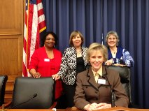

Marilyn Falksen and Becky Gaul join two other Lobby Corps members at the AAUW "watch party" for the launch of "Solving the Equation: The Variables for Women's Success in Engineering and Computing."

Book Drive continues through April 10.

Book collection continues and we now have plenty of space to store books thanks to Patrick Ferree's generous offer to let us store sorted books in his garage. So remind folks to donate books SOON.

Donors can deposit good, clean, saleable books in the book collection bin at the Falls Church Community Center between March 1 and April 5.  Or they can bring them to Mary's during book sorting Youman's (4419 N. 18th Street, Arlington), 10-4 on Saturdays or call the Youmans (703/528-8993) to other arrangements.

Donations are 50% tax deductible, value assigned by the donor.  Sale profits fund scholarships and grants for local girls and AAUW’s national scholarship program for women and girls.  So when you donate a book you help send a girl to college.

Book Sale – April 17 and 18

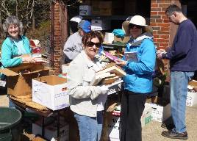

Book sorting continues on Saturdays through April 11. Come to sort at 4419 N. 18th Street, Arlington). We sort in the driveway from 10am to 4pm; we are outdoors, so dress for the weather. We invite all book sorters to share in a simple lunch each week, so you don’t have to worry about getting hungry. And, remember, book sorters get first crack at the books!

Call Mollie Jewell (703-941-5643) or Mary Youman (703-528-8993) with your questions or to volunteer.

**Book Sale Volunteer Opportunities**



As always, we need your help with the book sale! We're recruiting people to help with 3 main jobs:

1. Book Sale Setup and Training ... Thus, April 16
2. Selling books… at sale (April 17 and 18)
3. Posting publicity … April 12-April 18.

Book sale setup

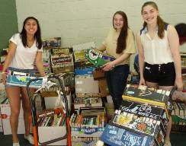

And, we also have a host of other jobs - Sign up at book sorting, call Mollie Jewell (703-941-5643, or fill out the online staffing sheet by clicking on the link: [Book-sale-signup](https://docs.google.com/spreadsheets/d/1H2sQR1ARmFH6G-2BK9QftJiFGENpTAbgVxXtPnmaiJ4/edit?usp=sharing)

Note that this spreadsheet now has 4 tabs: one for Book Sellers, Sorting Season jobs, Week of the Sale, and Publicity/Signs.

**Book Sale Posters**

Publicity is important because it draws paying customers. In addition to our announcements and ads in papers and on radio and TV stations, the posters draw many customers. That’s where you come in. Starting April 1, hang the posters. Then each time you return, make sure the sign is still up. Many stores change their policies each year or regularly remove signs - so keep at it!

**Selling**

Selling books is what it’s all about! The job is comparable to retail clerking; if you like books, people, or money, it’s really lots of fun. Sign up for at least one 3-hour shift!

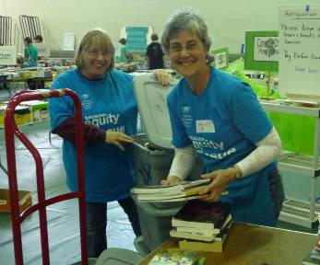

This year, we will hold a training session for book sellers on Thursday evening, April 16 (the night before the sale) at the Community Center.

We are researching accepting credit cards this year, so there's more to learn about selling. Be sure to come to the Thursday night training!

**Volunteer for many jobs!**

Remember, you don't need to limit yourself to just one job. Sign -up at the meeting. If you have any questions or suggestions, or wish to volunteer, call Mollie Jewell 703/941-5643.

April 17

**Book Sale Celebration and Dinner**



After helping out at the book sale, plan to attend the annual Book Sale Celebration on Saturday night, April 17. Returning to a former tradition, we'll be gathering at the new Anthony's (Rt. 50 and Annandale Road) in Falls Church right after the sale closes. This is an event for book sale workers and family. Don’t miss this very special (and fun) event -- it’s a great chance to celebrate our success.

AAUW Educational Foundation

How our book sale helps...

In addition to our local scholarships and grants, our branch book sale benefits the programs of AAUW's Educational Foundation. The AAUW Educational Foundation, which is the largest source of funding exclusively for graduate women in the world, supports aspiring scholars around the globe, teachers and activists in local communities, women at critical stages of their careers, and those pursuing professions where women are underrepresented. This year, our branch has just begun funding the endowment for a career development, which we expect to fully fund in the next few years.

**Book donations**

**The books are coming in.** We already have a lot of books and the collection bin at the Community Center. If you, your friend, or neighbor has good, saleable books, we’d love to have them.

**Guidelines for book donations.** We’ve gotten selective about accepting books. We just can’t sell magazines, textbooks, encyclopedias, old reference books, and books that are damaged, moldy or in poor condition – no matter how meaningful they are to the donor. So please tell donors that we are accepting only saleable books in good condition and remind them about the list of things we can’t accept. The other books, unfortunately, must be put in the trash.

**Publicity you can use.**

Below are two blurbs that you can use to publicize the book sale in your local community newsletter, list serve, or other outlet.

**Used Book Sale**

**April 17 and 18**



**Fri. April 17...…..9 a.m. - 9 p.m.**

**Sat. April 18….....9 a.m. - 4 p.m.**

**Buy a book, send a girl to College**

Falls Church Community Center

223 Little Falls Rd, Falls Church VA

More information call (703) 941-5643

http://fallschurcharea-va.aauw.net/booksale/

  Falls Church Area Branch



FC AAUW Used Book Sale

April 17 and 18

Buy a book, send a girl to college

Fri. April 17...…..9 a.m. - 9 p.m.

Sat. April 18….....9 a.m. - 4 p.m.

Benefits women’s scholarship programs

Falls Church Community Center

223 Little Falls Rd, Falls Church VA

For more information call (703) 941-5643

http://fallschurcharea-va.aauw.net/booksale/

Falls Church Area AAUW

If you are accepting book donations from your friends, you can cut out and give them the following receipt:

|  |
| --- |
| **AAUW Educational Equity Booksale**  Falls Church Community Center  April 17 and 18  *Promoting education and equity for women and girls*  Thank you for your donation of:  _________ Soft cover books  _________ Hard cover books  _________ Other:  Value to be established by donor.  50% Tax deductible.  Benefits AAUW scholarships/projects for girls. |

**May Book Group Selection**

We skip April, so our next meeting will be **Tuesday, May 19**th, host TBD,  The book is **I Am Malala:  The Girl Who Stood Up for Education and Was Shot by the Taliban** by Malala Yousafzai with journalist Christina Lamb.  The book recounts the early life of the Pakistani schoolgirl who spoke out against the Taliban, was shot for her defiance, and became a powerful symbol for girls' universal right to an education.  We hope you can join us in May.

**Movie Blog**

The Movie Group is still viewing the latest from Hollywood! If you want to read one member’s take on the films of the day, go to Susan Conklin’s blog [http://suzismovies.blogspot.com/](http://www.google.com/url?q=http%3A%2F%2Fsuzismovies.blogspot.com%2F&sa=D&sntz=1&usg=AFQjCNGhArA4KMLZdCFXcpjl6OeM8YJfvQ)  And consider joining the group any Wednesday; contact Kitty Richardson [kittyrichardson6@gmail.com](mailto:kittyrichardson6@gmail.com) for information.



**Two upcoming events at George Mason University:**

The first is in conjunction with Equal Pay Day and cancelled previously due to weather.  AAUW is invited.  There is no registration - just show up.  The second is the film we help support with a Special Projects Grant to pay for half the screening fee.

**Sojourner Truth and Equal Pay Day event at George Mason University.**

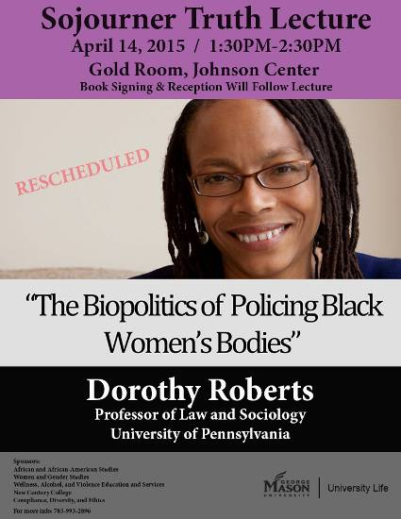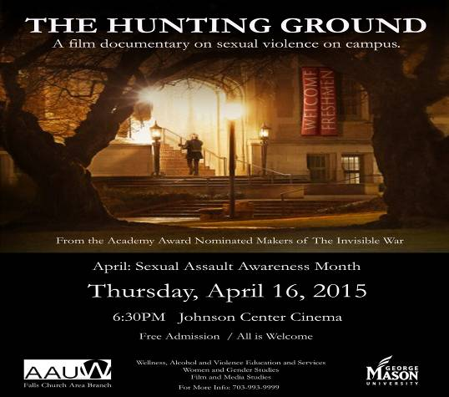

**CALENDAR OF EVENTS**

April 16, 17, 18 Book Sale, FC Community Center

April 18-19 AAUW-VA Conference, Charlottesville, VA

May 11 Scholarship Awards meeting, 7:30pm, location TBA

June 8 Planning Picnic

Empowering Women Since 1881

The American Association of University Women promotes equity for all women and girls, lifelong education, and positive societal change. In principle and practice AAUW values and seeks a diverse membership. There shall be no barriers to full participation in this organization on the basis of gender, race, creed, age, sexual orientation, national origin, or disability.

[http://aauw-va.aauw.net](http://www.google.com/url?q=http%3A%2F%2Faauw-va.aauw.net&sa=D&sntz=1&usg=AFQjCNGm0MXV_5DJXdrPpTwkxLbkPwj-9A)